- Launch one EC2 using Amazon Linux 2 image and add a script in user data to install Apache.
Open AWS console and start creating new instance with Amazon linux OS then configure the instance with required family of instance such as t3,t2,medium,small, etc..then select a key .pem then create a security group with your requirement port numbers and write a script in the user data for running a service while launching a instance only then hit launch instance. Your instance is created and now connect to your terminal either with your ssh link or ec2 instance connect.
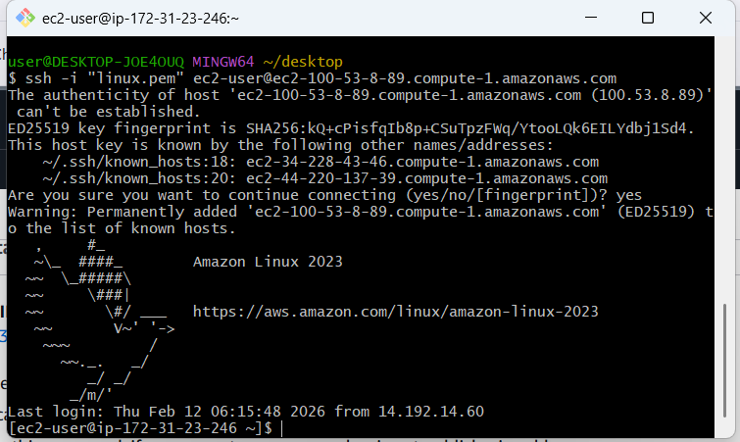
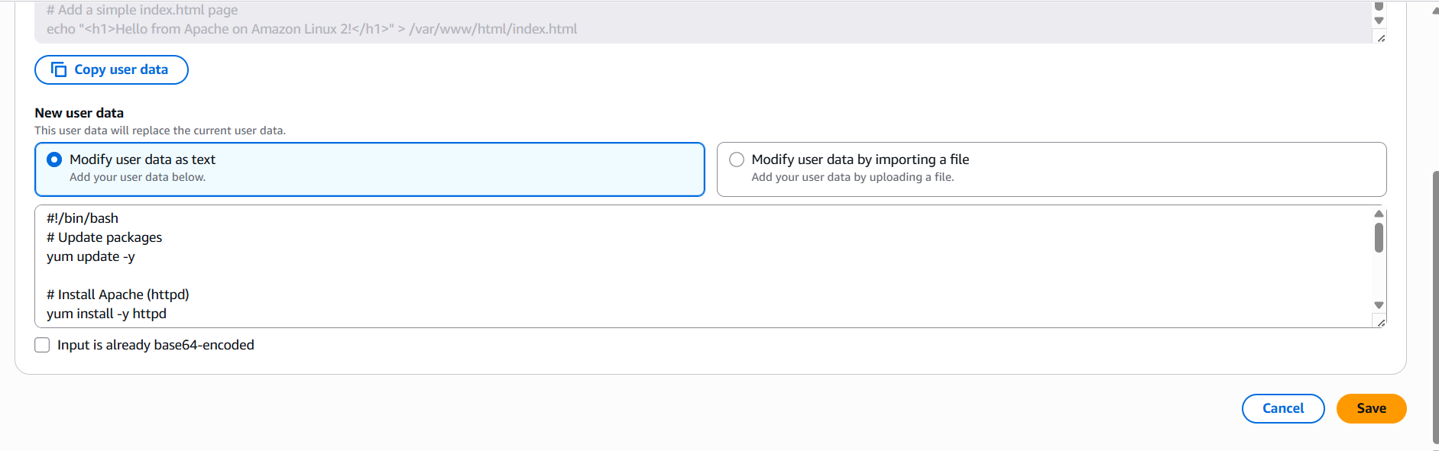
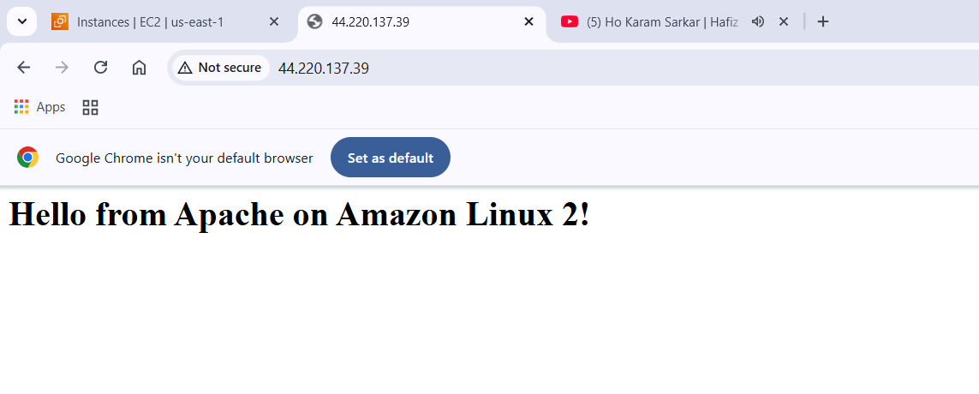
- Launch one EC2 using Ubuntu image and add a script in user data to install Nginx.
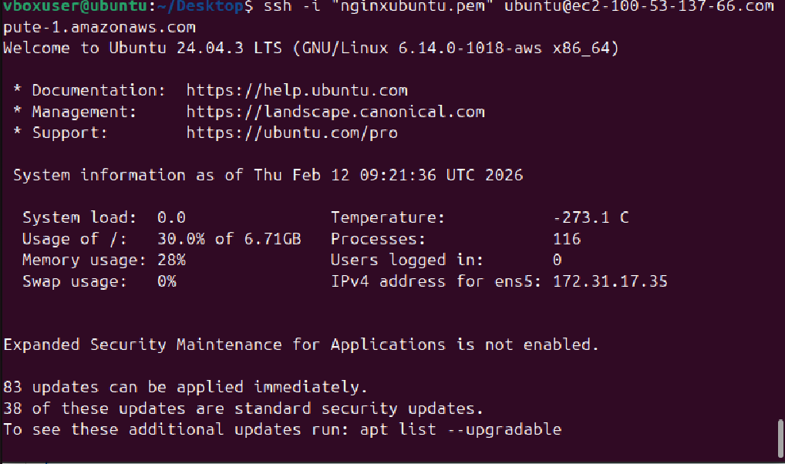
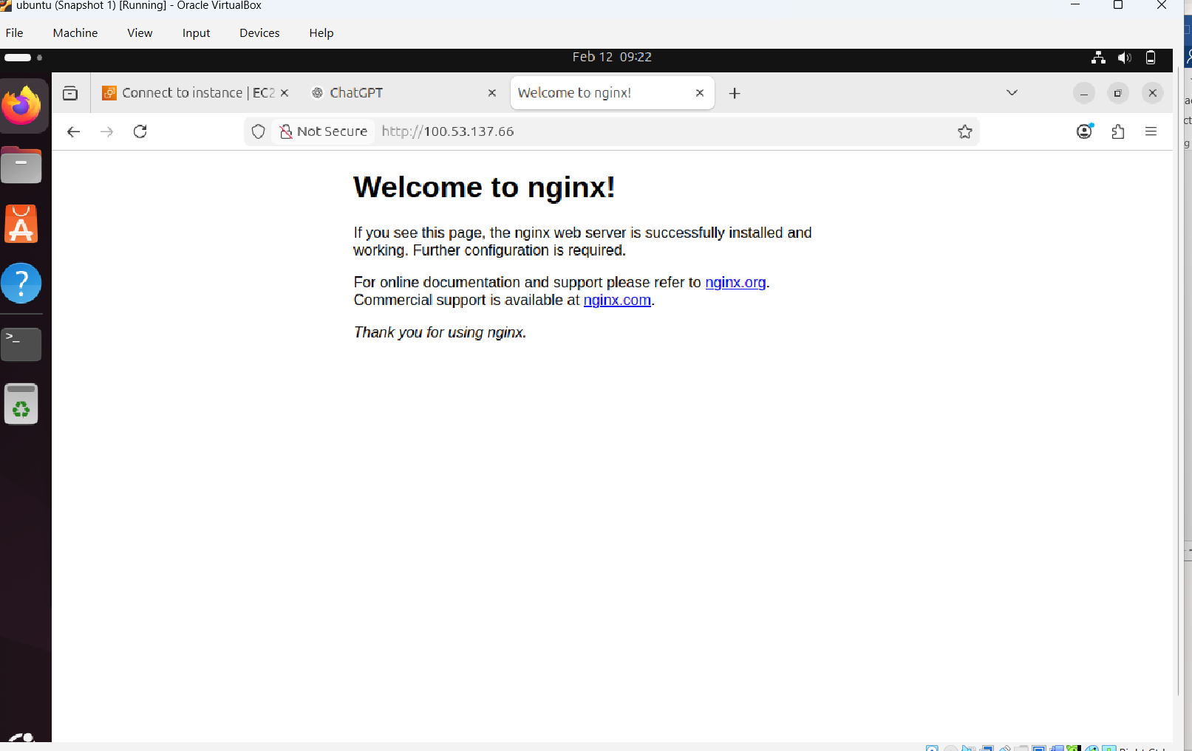
- Launch one Windows server and install Tomcat on Windows.
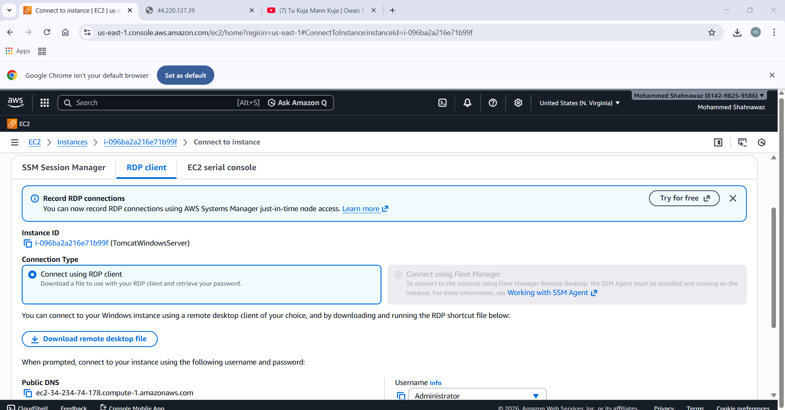

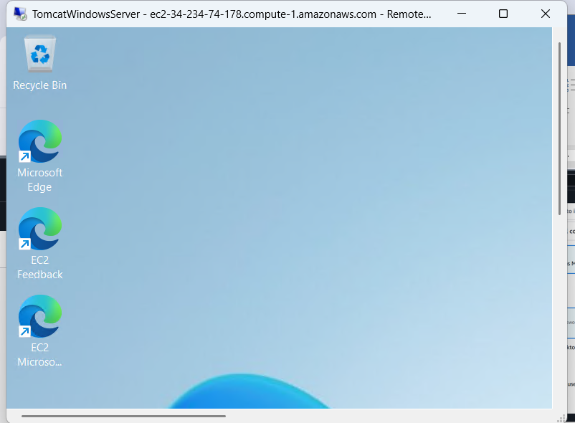

- Take a snapshot of the instance created in Task 1.
- Go to EC2 → Instances → Select your instance.
- Scroll down to Storage → Volumes.
- Note the Volume ID of the root (boot) disk and any attached data disks.
- In the AWS Console:
- Go to EC2 → Elastic Block Store → Volumes.
- Select the volume → Actions → Create Snapshot.
- Add a description (e.g., “Snapshot of Ubuntu web server root volume”).
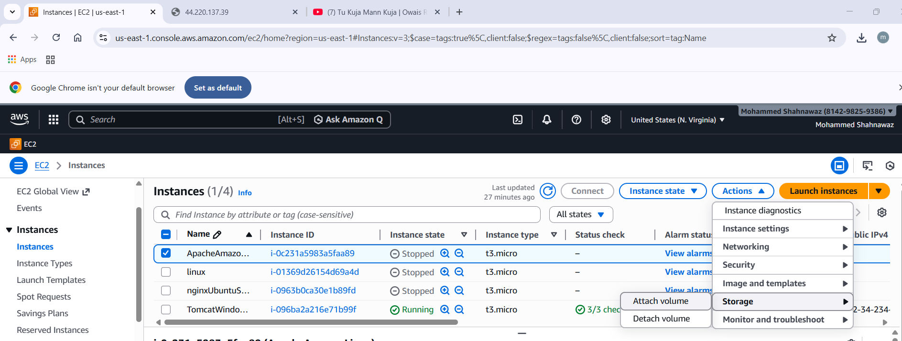

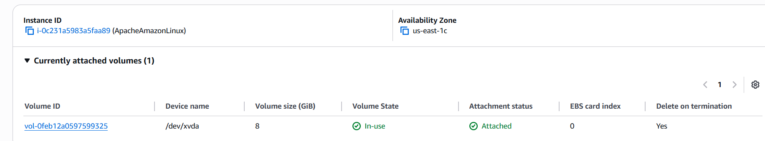
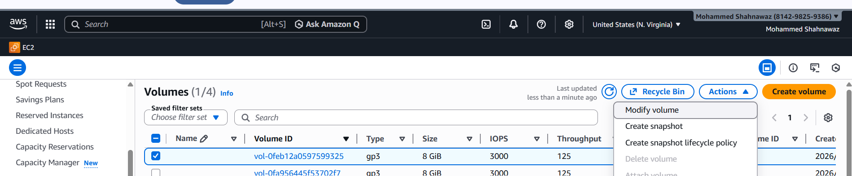
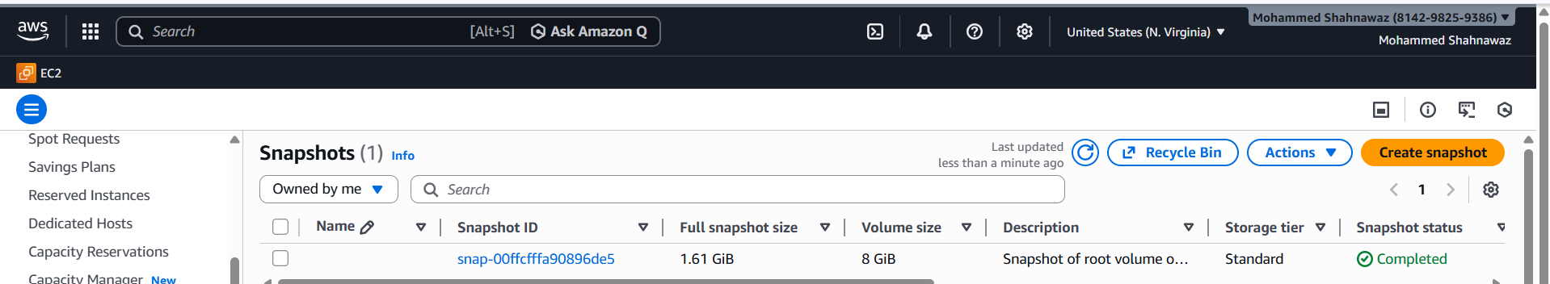

- Launch any EC2 using the spot purchasing option.
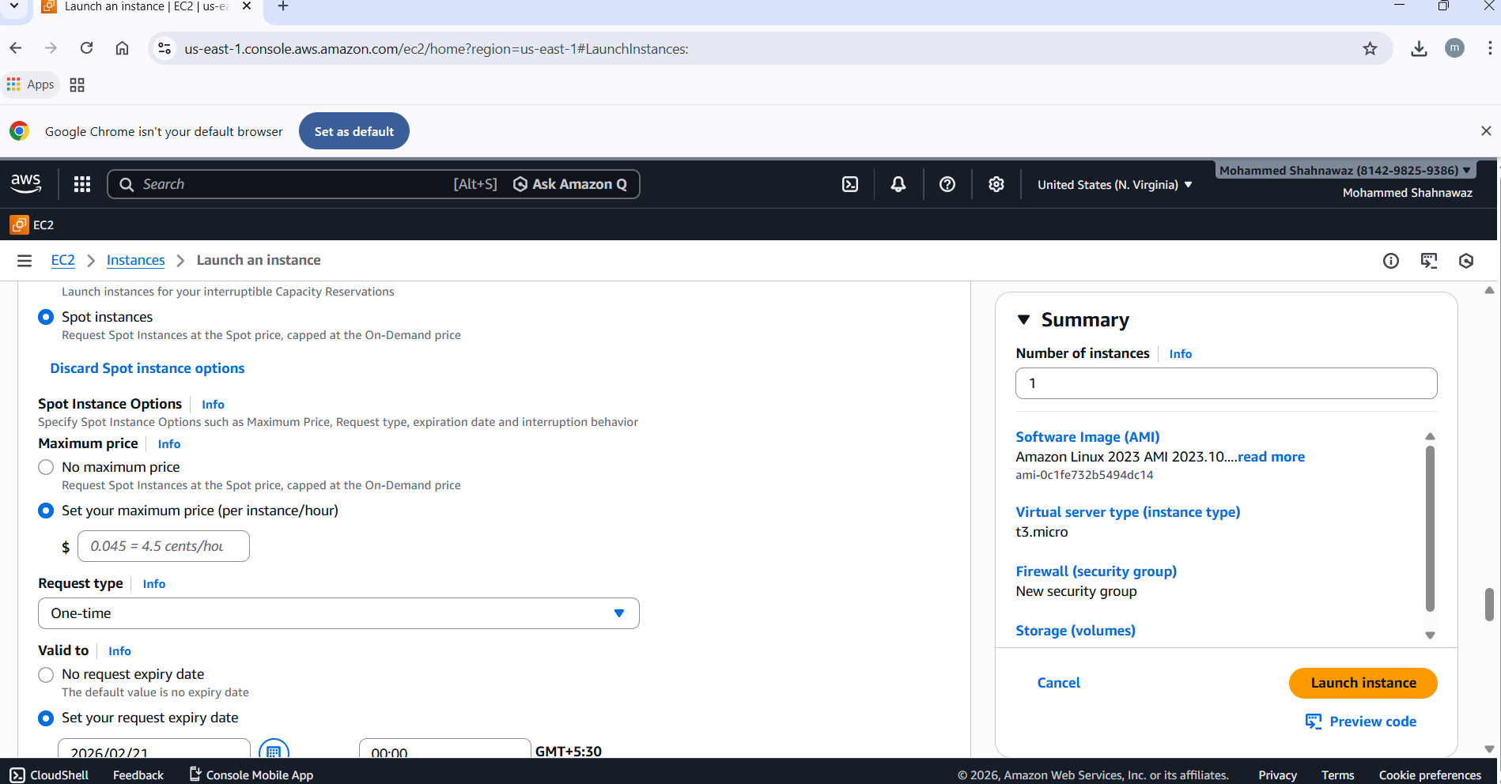
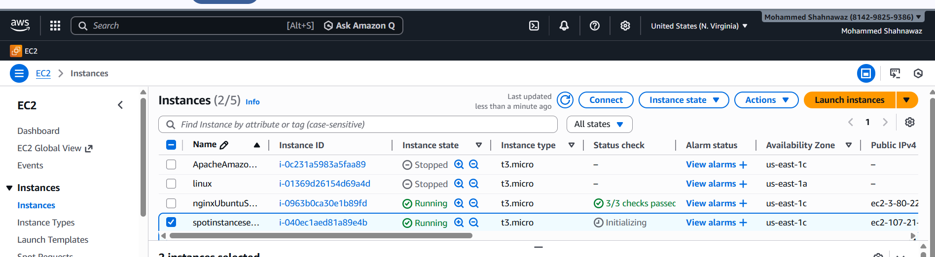

- Enable termination policy on the EC2 created in Task 2.
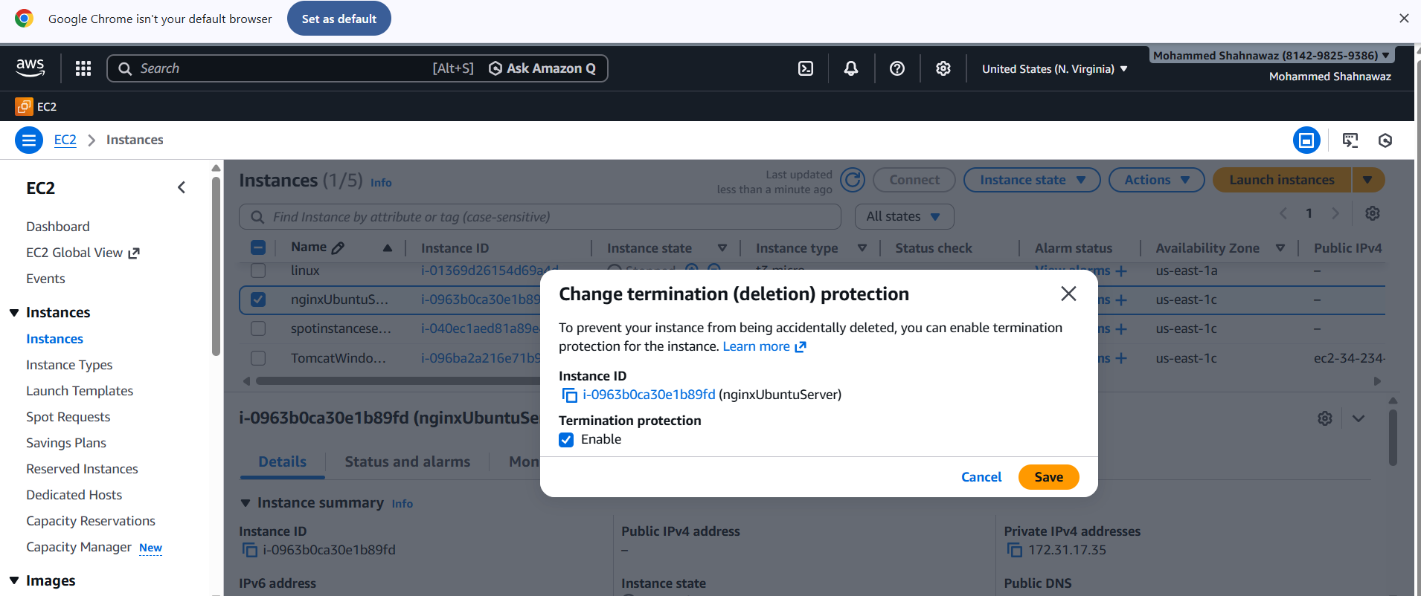

  - Launch one EC2 using AWS CLI.
